**Project Title**

**STATIC WEBSITE USING AZURE SERVICEES**

**Sponsor: Dear Future Ready Talent,**

I want to express my sincere thanks for your crucial help and support during our project. Your sponsorship made a big difference in our success, and we're truly thankful for your contributions.

**Project Overview:**

The project entails the creation and deployment of a static website leveraging Azure services, including Resource Group,Azure Storage Account ,Azure Web Apps. This endeavor seeks to establish a cost-effective, scalable, and secure online presence, enabling visitors to access essential information. The project's key deliverables encompass website design, content creation, Azure services setup, testing, deployment, and documentation. By utilizing Azure's infrastructure, the website will not only provide a user-friendly interface for engagement but also ensure that it can easily adapt to increased traffic and maintain the highest level of security.

**Project Synopsis:**

What is the core idea of your project?

The core idea of the static website project for the coffee cafe is to create an online platform that effectively represents the cafe's identity and offerings, providing visitors with essential information such as menu options, location, contact details, and the cafe's ambiance. This website serves as an online extension of the cafe, offering a user-friendly interface that mirrors the cafe's atmosphere, ensuring visitors can easily access information and be enticed to visit in person. The website's design and content are tailored to capture the essence of the cafe, aiming to attract new customers, engage existing ones, and enhance the cafe's online presence.

HOME PAGE:

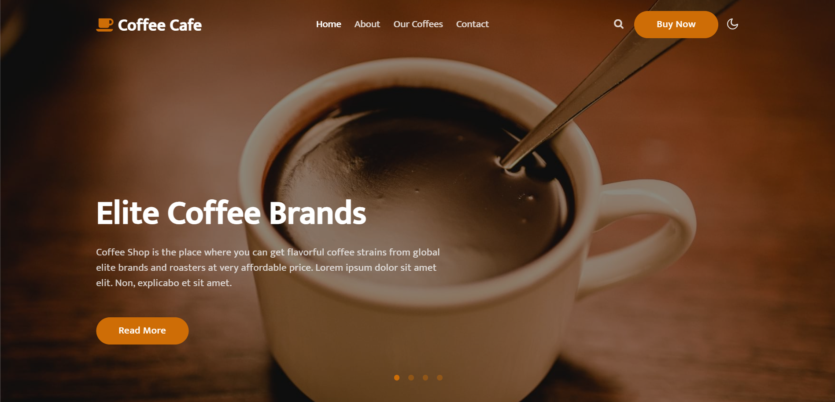

ABOUT US:

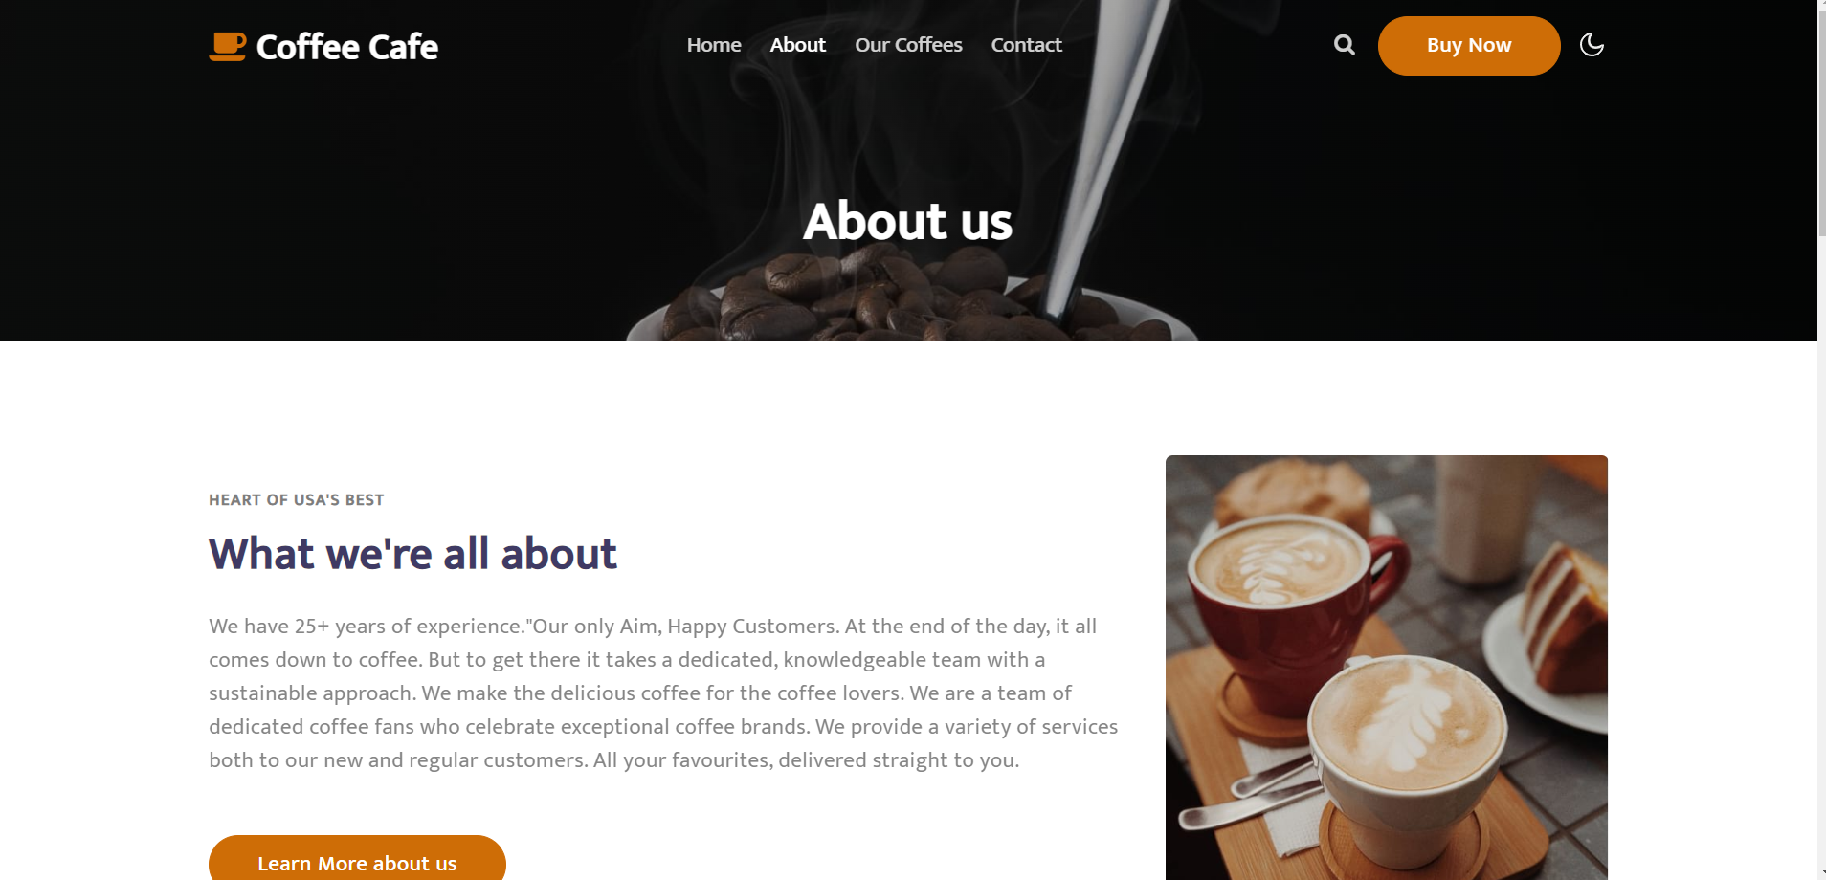

OUR COFFEE:

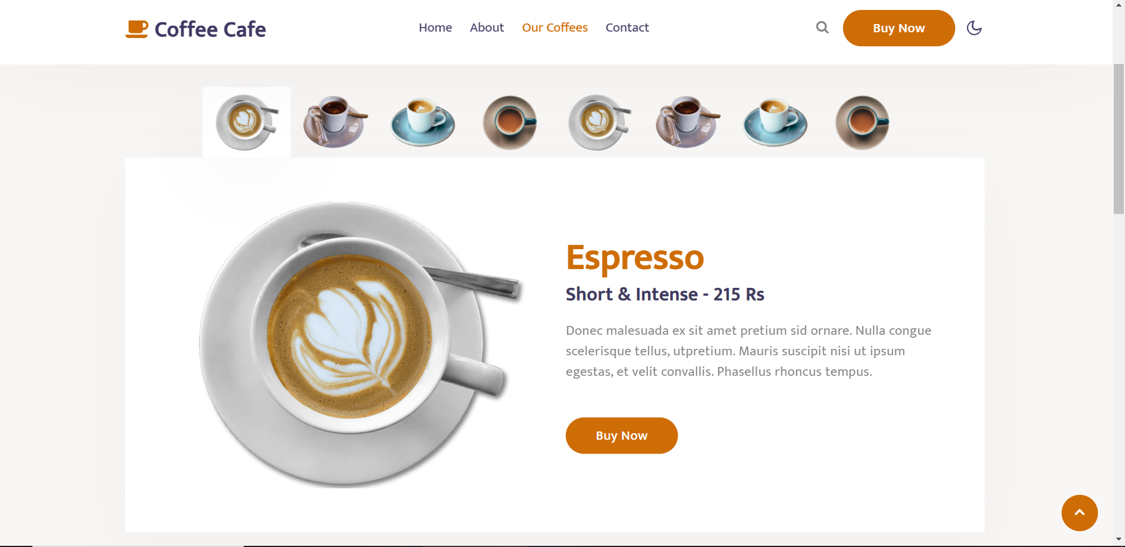

CONTACT:

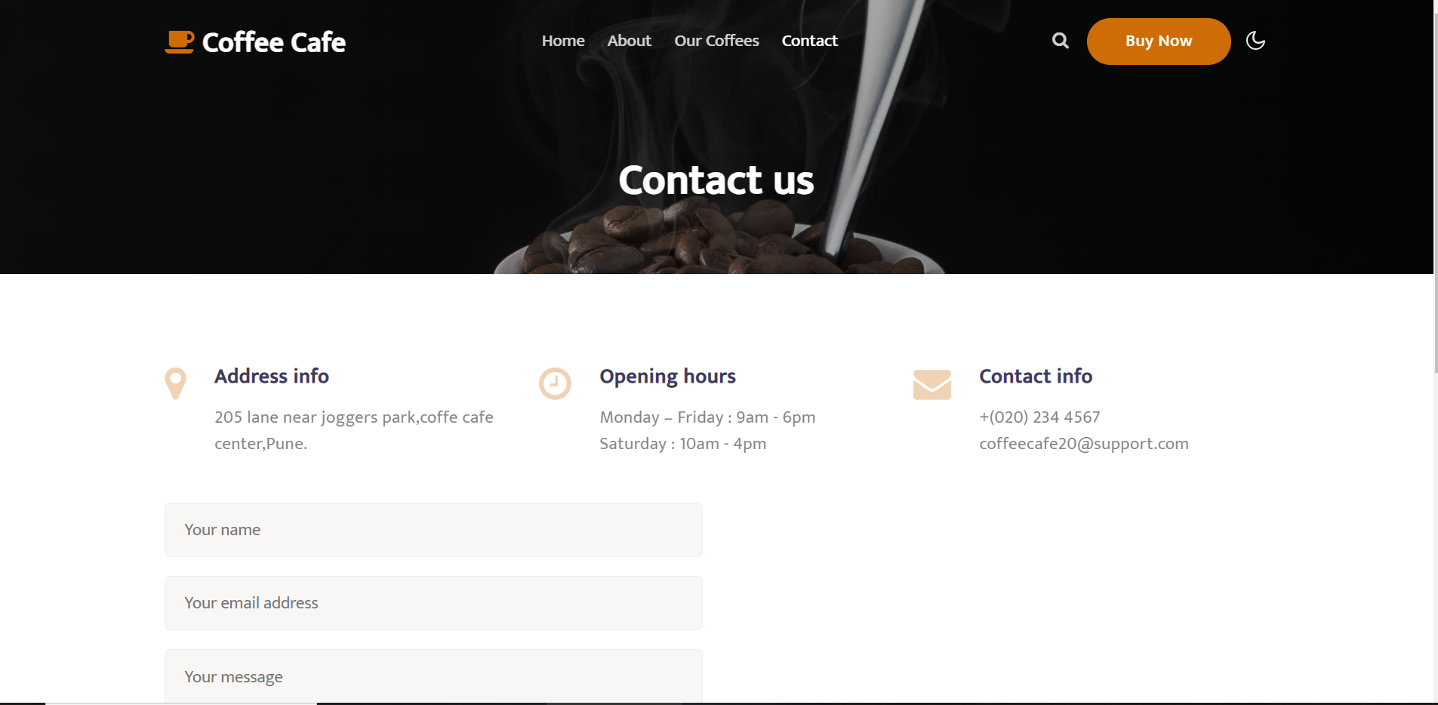

Github Account:

[snehagawde.github.io/Coffee-Cafe/](https://snehagawde.github.io/Coffee-Cafe/)